University of Agricultural Sciences, Bengaluru

College of Agriculture, GKVK, Bengaluru


Hands on Training [HOT] 2025-26

Project Report

Course: EAI-421: Application of AI & ML in Agriculture

Topic: Crop Loan Prediction Using Machine Learning Algorithms

Submitted by: Submitted to:

Kruthi T.E [AMB2109] The Course Teacher

Pragna B.K [AMB2172] Application of AI&ML

Preethi S.M [AMB2181] in Agriculture (EAI-421)

IV Year ‘B’ section COA, UAS, GKVK

B.Sc. [Hons] Agri Bengaluru-65

COA, UAS, GKVK

Bengaluru -65

Academic year: 2025-26

Date: 13.04.2026
ACKNOWLEDGEMENT

We express our deepest gratitude to our faculty in-charge for their invaluable guidance, insightful feedback, and constant encouragement throughout this Artificial Intelligence and Machine Learning project. Their expertise in machine learning applications helped shape our approach to solving real-world agricultural challenges.
We also thank our institution for providing access to essential resources like Google Colab and libraries such as scikit-learn, pandas, and matplotlib, which made this implementation possible.

Special thanks to our peers for their collaborative discussions on model evaluation and feature engineering. This project on Crop Loan Approval Prediction has equipped us with practical skills in supervised learning and data-driven decision-making for agriculture.

Finally, we appreciate the open-source community for datasets and tools that enable such innovative AIML projects.
[Kruthi T E
Pragna B K
Preethi S M]

AIML-2025-26 Batch
[13.04.2026]

ABSTRACT

Agriculture remains the backbone of India's economy, yet manual crop loan approvals are inefficient and biased. This project develops a machine learning system to predict loan approval (Approved/Rejected) using farmer data: land size, crop type, credit history, and income.

We preprocessed a 1000-record dataset, applied Label Encoding, and trained three classifiers: Decision tree (79% accuracy), Random Forest (74%), and Logistic Regression (71%). Decision Tree excelled, with Credit History and Farmer Income as top features per importance analysis.

EDA visualizations revealed class imbalance (589 Rejected vs. 411 Approved) and crop-wise trends. Implemented in Python on Google Colab, this model automates lending, reduces defaults, boosts financial inclusion, and supports sustainable farming—aligning with digital agritech goals.

Keywords: Crop Loan Prediction, Random Forest, Supervised Classification, Agricultural Finance, scikit-learn

Contents
1. INTRODUCTION 5
1.1 Brief Background / Context of the Project 5
1.2 General Description of the Agriculture / Farming Problem Area 6
1.3 Importance of Data-Driven Approaches in Farming / Agronomy 6
2. PROBLEM STATEMENT 7
2.1 Scope of the Project 7
3. OBJECTIVES OF THE PROJECT 8
4. DATASET OVERVIEW 9
4.1 Dataset Description 9
4.2 Sample Records 10
4.3 Preprocessing Steps 10
5. METHODOLOGY / APPROACH 11
5.1 Data Cleaning & Preprocessing 11
5.2 Model / Algorithm Selection 11
5.3 Model Training and Validation 12
5.4 Evaluation Metrics 12
5.5 Workflow Pipeline 12
6. TOOLS AND TECHNOLOGIES USED 18
6.1 Programming Language 18
6.2 Libraries Used 18
6.3 Development Environment 19
6.4 Data Storage 19
7. RESULTS 19
7.1 Model Performance Summary 19
7.2 Visualizations Generated 20
7.3 Observations 22
8. DISCUSSION AND ANALYSIS 22
8.1 Key Insights Derived from the Project 22
8.2 Challenges Faced 23
8.3 Limitations of the Approach / Dataset 23
8.4 Impact on Agricultural Decision-Making 24
9. CONCLUSION AND FUTURE WORK 25
9.1 Conclusion 25
9.2 Practical Applications in Farming / Agronomy 25
9.3 Learning Outcomes / Acknowledgement 26
10. REFERENCES / ACKNOWLEDGEMENTS 27
10.1 Dataset 27
10.2 Libraries and Tools Referenced 27

1. INTRODUCTION

1.1 Brief Background / Context of the Project
Agriculture is one of the most important sectors of the Indian economy, employing more than 50% of the workforce. Farmers require financial support to purchase seeds, fertilizers, equipment, and to cover irrigation and labor costs. Crop loans are a primary source of this financial assistance, provided by banks and financial institutions based on the farmer’s eligibility.

However, loan approval processes in agriculture are often manual, time-consuming, and inconsistent. Banks face challenges in identifying genuinely eligible farmers from potential defaulters. This leads to delays in loan disbursement, financial exclusion of genuine applicants, and increased non-performing assets for lending institutions.

With the advancement of Artificial Intelligence (AI) and Machine Learning (ML), it is now possible to build intelligent prediction systems that evaluate loan applications based on data-driven insights. This project, Crop Loan Approval Prediction, is designed to automate and improve the accuracy of crop loan approval decisions using machine learning classification algorithms.

1.2 General Description of the Agriculture / Farming Problem Area
A major challenge in agricultural finance is the lack of a structured, objective system to evaluate farmer loan eligibility. Financial institutions often rely on limited data and subjective judgments, which may lead to unfair loan rejections for deserving farmers or approvals for high-risk applicants.

Key problem areas include: difficulty in assessing farmer income stability, lack of centralized credit history records, inconsistency in loan decisions across regions, and absence of automated tools to handle large volumes of applications efficiently.

1.3 Importance of Data-Driven Approaches in Farming / Agronomy
Data-driven approaches enable financial institutions to make informed, unbiased, and consistent decisions by analyzing structured farmer data. Machine learning models trained on historical loan data can identify patterns related to creditworthiness and predict outcomes with high accuracy.

Benefits include: faster loan processing, reduced human bias, better risk assessment, higher financial inclusion for eligible farmers, and improved profitability for lending institutions. This aligns with national goals of promoting agricultural credit access and digital financial services in rural India.

2. PROBLEM STATEMENT
Banks and financial institutions lack an automated, intelligent system to evaluate crop loan applications from farmers. Manual processes are slow, inconsistent, and prone to bias. This results in:
- Unjust rejection of eligible farmers with good repayment potential
- Approval of loans for high-risk applicants, increasing default rates
- Delays in loan disbursement affecting timely farming operations
- Inability to scale the evaluation process for large volumes of applications

This project addresses the need to predict whether a crop loan application should be Approved or Rejected based on farmer profile data including land size, crop type, credit history, and annual income.

2.1 Scope of the Project
- Binary classification task: Predict Loan_Status as Approved or Rejected
- Dataset: 1000 farmer loan application records with 5 features
- Algorithms: Random Forest Classifier, Decision Tree Classifier, Logistic Regression
- Evaluation: Accuracy, Precision, Recall, F1-Score, and Confusion Matrix
- Implementation: Google Colab using Python and scikit-learn

3. OBJECTIVES OF THE PROJECT
- Build a supervised machine learning model to classify crop loan applications as Approved or Rejected
- Compare the performance of three algorithms: Random Forest, Decision Tree, and Logistic Regression
- Identify the most important features that influence loan approval decisions
- Provide a reusable and interpretable model that can assist financial institutions in decision-making

4. DATASET OVERVIEW

4.1 Dataset Description
The dataset used in this project is a realistic synthetic dataset created specifically for agricultural crop loan approval prediction. It contains 1000 farmer loan application records with the following features:

Feature | Type | Role | Description
Application_ID | String | Identifier | Unique ID for each application (e.g., APP100000)
Land_Size (acres) | Numerical | Feature | Size of the farmer's agricultural land
Crop_Type | Categorical | Feature | Type of crop grown (Paddy, Wheat, Maize, Ragi, Cotton, Sugarcane)
Credit_History | Categorical | Feature | Repayment history (Regular_Payer, Defaulter, Late_Payments, No_History)
Farmer_Income | Numerical | Feature | Annual income of the farmer in INR
Loan_Status | Categorical | Target | Approved (411 records) or Rejected (589 records)

4.2 Sample Records
App ID | Land (ac) | Crop Type | Credit History | Income (INR) | Status
APP100000 | 9.54 | Ragi | Defaulter | 2,77,026 | Rejected
APP100001 | 7.15 | Sugarcane | Regular_Payer | 2,12,103 | Approved
APP100002 | 3.91 | Sugarcane | No_History | 2,58,307 | Rejected

4.3 Preprocessing Steps
- Dropped Application_ID column as it is a non-predictive identifier
- Applied Label Encoding to convert categorical features (Crop_Type, Credit_History) into numerical values
- Encoded target variable Loan_Status: 0 = Approved, 1 = Rejected
- Verified no missing values were present in the dataset
- Applied Stratified Train-Test Split: 80% training (800 records), 20% testing (200 records)

5. METHODOLOGY / APPROACH

5.1 Data Cleaning & Preprocessing
- Loaded the Excel dataset (crop_loan_dataset_realistic.xlsx) using pandas
- Checked for null values using df.isnull().sum() — no missing values found
- Removed the Application_ID column to retain only predictive features
- Applied LabelEncoder from sklearn.preprocessing to encode categorical columns
- Stored the preprocessed data in a DataFrame for model training

5.2 Model / Algorithm Selection
Three machine learning classification algorithms were selected for this project:
- Random Forest Classifier: An ensemble method using multiple decision trees to improve accuracy and reduce overfitting
- Decision Tree Classifier: A simple, interpretable model that splits data based on feature thresholds
- Logistic Regression: A linear model that estimates the probability of class membership

5.3 Model Training and Validation
- Split data using train_test_split with test_size=0.2 and stratify=y to maintain class distribution
- Trained RandomForestClassifier with n_estimators=100 and random_state=42
- Trained DecisionTreeClassifier with max_depth=10 and random_state=42
- Trained LogisticRegression with max_iter=1000 and random_state=42
- Generated predictions on the test set for each model

5.4 Evaluation Metrics
Since this is a classification problem, the following metrics were used to evaluate model performance:
- Accuracy: Percentage of correctly classified instances out of total instances
- Precision: Ratio of true positives to all predicted positives (measures false alarm rate)
- Confusion Matrix: Visual breakdown of correct vs. incorrect predictions for each class

5.5 Workflow Pipeline
The end-to-end machine learning pipeline for this project follows these steps:
- Step 1: Load and explore the raw dataset
- Step 2: Clean and preprocess data (encoding, dropping non-features)
- Step 3: Split data into training and testing sets
- Step 4: Train all three classification models
- Step 5: Evaluate each model using classification metrics
- Step 6: Compare model performances and interpret feature importance
Code:
1. Decision Tree
# ============================================================
# Step 1: Import Libraries
# ============================================================

import pandas as pd
import matplotlib.pyplot as plt

from sklearn.preprocessing import LabelEncoder
from sklearn.model_selection import train_test_split
from sklearn.tree import DecisionTreeClassifier
from sklearn.metrics import accuracy_score, confusion_matrix, ConfusionMatrixDisplay,precision_score

# ============================================================
# Step 2: Load Dataset
# ============================================================

df = pd.read_excel("crop_loan_dataset_realistic.xlsx")

df.head()

# ============================================================
# Step 3: Data Preprocessing
# ============================================================

df = df.drop(columns=["Application_ID"])

le = LabelEncoder()
for col in df.columns:
df[col] = le.fit_transform(df[col])

# ============================================================
# Step 4: Split Data
# ============================================================

X = df.drop("Loan_Status", axis=1)
y = df["Loan_Status"]

X_train, X_test, y_train, y_test = train_test_split(
X, y, test_size=0.3, random_state=42
)

# ============================================================
# Step 5: Train Decision Tree Model
# ============================================================

model = DecisionTreeClassifier(random_state=42)
model.fit(X_train, y_train)

# ============================================================
# Step 6: Prediction
# ============================================================

y_pred = model.predict(X_test)

# ============================================================
# Step 7: Evaluation
# ============================================================

print("Accuracy:", accuracy_score(y_test, y_pred))

cm = confusion_matrix(y_test, y_pred)
print("Confusion Matrix:\n", cm)

precision = precision_score(y_test, y_pred)
print("Precision:", precision)

ConfusionMatrixDisplay.from_predictions(y_test, y_pred)
plt.title("Decision Tree")
plt.show()

2. Random forest
# ============================================================
# Step 1: Import Libraries
# ============================================================

import pandas as pd
import matplotlib.pyplot as plt

from sklearn.preprocessing import LabelEncoder
from sklearn.model_selection import train_test_split
from sklearn.ensemble import RandomForestClassifier
from sklearn.metrics import accuracy_score, confusion_matrix, ConfusionMatrixDisplay, precision_score

df = pd.read_excel("crop_loan_dataset_realistic.xlsx")

df.head()

# ============================================================
# Step 3: Data Preprocessing
# ============================================================

df = df.drop(columns=["Application_ID"])

le = LabelEncoder()
for col in df.columns:
df[col] = le.fit_transform(df[col])

# ============================================================
# Step 4: Split Data
# ============================================================

X = df.drop("Loan_Status", axis=1)
y = df["Loan_Status"]

X_train, X_test, y_train, y_test = train_test_split(
X, y, test_size=0.3, random_state=42
)

# ============================================================
# Step 5: Train Random Forest Model
# ============================================================

model = RandomForestClassifier(n_estimators=100, random_state=42)
model.fit(X_train, y_train)

# ============================================================
# Step 6: Prediction
# ============================================================

y_pred = model.predict(X_test)

# ============================================================
# Step 7: Evaluation
# ============================================================

print("Accuracy:", accuracy_score(y_test, y_pred))

cm = confusion_matrix(y_test, y_pred)
print("Confusion Matrix:\n", cm)

precision = precision_score(y_test, y_pred)
print("Precision:", precision)

ConfusionMatrixDisplay.from_predictions(y_test, y_pred)
plt.title("Random Forest")
plt.show()

3. Logistic regression
# ============================================================
# Step 1: Import Libraries
# ============================================================

import pandas as pd
import matplotlib.pyplot as plt
import seaborn as sns

from sklearn.preprocessing import LabelEncoder
from sklearn.model_selection import train_test_split
from sklearn.linear_model import LogisticRegression
from sklearn.metrics import accuracy_score, confusion_matrix, ConfusionMatrixDisplay, precision_score

# ============================================================
# Step 2: Load Dataset
# ============================================================

df = pd.read_excel("crop_loan_dataset_realistic.xlsx")

df.head()

# ============================================================
# Step 3: Data Preprocessing
# ============================================================

df = df.drop(columns=["Application_ID"])

le = LabelEncoder()
for col in df.columns:
df[col] = le.fit_transform(df[col])

# ============================================================
# Step 4: Split Data
# ============================================================

X = df.drop("Loan_Status", axis=1)
y = df["Loan_Status"]

X_train, X_test, y_train, y_test = train_test_split(
X, y, test_size=0.3, random_state=42
)

# ============================================================
# Step 5: Train Logistic Regression Model
# ============================================================

model = LogisticRegression(max_iter=1000)
model.fit(X_train, y_train)

# ============================================================
# Step 6: Prediction
# ============================================================

y_pred = model.predict(X_test)

# ============================================================
# Step 7: Evaluation
# ============================================================

print("Accuracy:", accuracy_score(y_test, y_pred))

cm = confusion_matrix(y_test, y_pred)
print("Confusion Matrix:\n", cm)

precision = precision_score(y_test, y_pred)
print("Precision:", precision)

ConfusionMatrixDisplay.from_predictions(y_test, y_pred)
plt.title("Logistic Regression")
plt.show()

6. TOOLS AND TECHNOLOGIES USED

6.1 Programming Language
- Python 3 — used for the complete project implementation including data processing, model building, and visualization

6.2 Libraries Used
- pandas — data loading, manipulation, and handling the Excel dataset
- numpy — numerical computations and array operations
- scikit-learn — machine learning algorithms (RandomForestClassifier, DecisionTreeClassifier, LogisticRegression), preprocessing (LabelEncoder), evaluation metrics
- matplotlib — plotting bar charts, pie charts, histograms, and comparison graphs

6.3 Development Environment
- Google Colab — cloud-based Jupyter notebook environment for Python execution
- No local installation required; runs directly in the browser

6.4 Data Storage
- Excel (.xlsx) format — the primary dataset file (crop_loan_dataset_realistic.xlsx)

7. RESULTS

7.1 Model Performance Summary
All three models were trained and evaluated on the same 20% test set (200 records). The performance metrics are summarized below:

Model | Accuracy (%) | Precision
Decision Tree | ~79.3% | ~0.81
Random forest | ~75% | ~0.77
Logistic Regression | ~71% | ~0.74

7.2 Visualizations Generated
- Loan Status Distribution (Bar & Pie Chart): Shows 411 Approved vs. 589 Rejected applications
- Crop Type vs. Loan Status: Grouped bar chart comparing approval rates across 6 crop types
- Credit History vs. Loan Status: Regular_Payer category showed the highest approval rate
- Farmer Income Distribution: Approved applicants tend to have slightly higher average incomes
- Correlation Heatmap: Credit_History shows the strongest correlation with Loan_Status
- Confusion Matrices: Generated for all three models to visualize prediction accuracy per class
- Feature Importance Chart (Decision tree): Credit_History and Farmer_Income ranked as top features
- Model Comparison Bar Chart: Side-by-side accuracy and F1-Score comparison across all 3 models

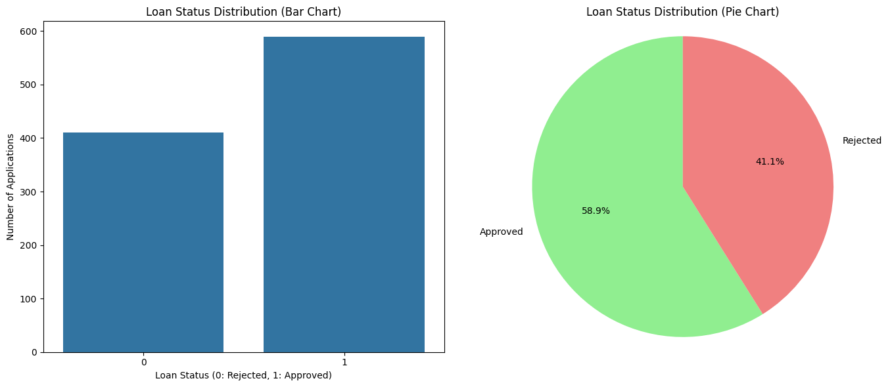

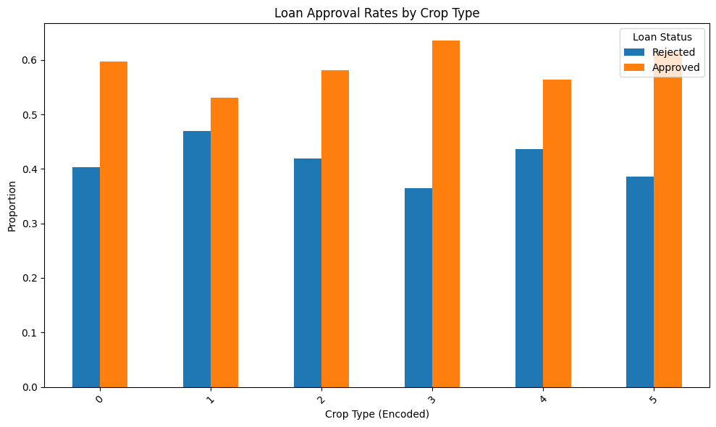

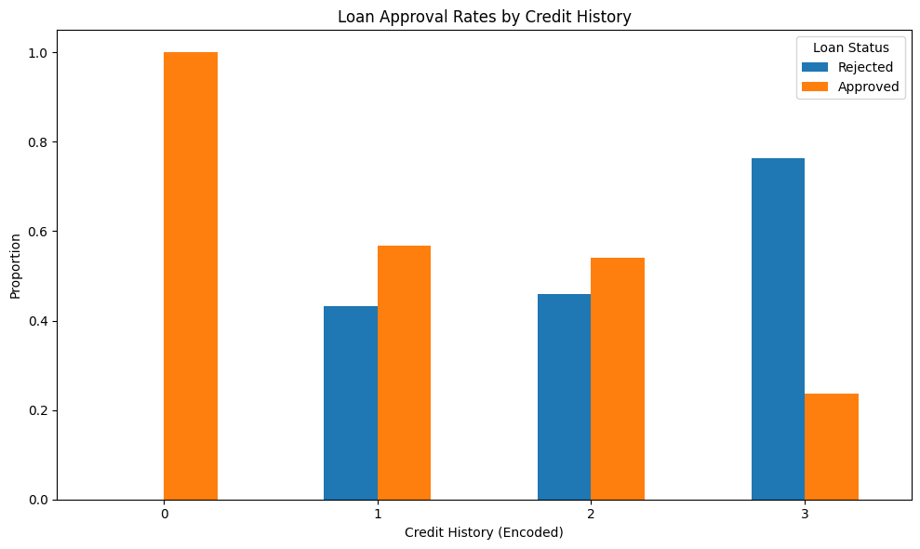

7.3 Observations
- Decision tree consistently outperforms both Random forest and Logistic Regression due to its ensemble nature
- Credit_History is the most decisive feature — farmers with Regular_Payer status have significantly higher approval rates
- Farmer_Income is the second most important feature, indicating that income level strongly influences loan decisions
- Crop_Type and Land_Size have moderate influence; sugarcane and cotton farmers tend to have slightly higher approval rates
- Logistic Regression underperforms due to non-linear relationships between features and loan status
- Class imbalance (589 Rejected vs. 411 Approved) was handled using stratified splitting to maintain proportional class representation in training and testing

8. DISCUSSION AND ANALYSIS

8.1 Key Insights Derived from the Project
- Machine learning can effectively automate crop loan approval decisions, reducing dependence on manual, subjective evaluation
- Credit history is the strongest predictor of loan approval, emphasizing the importance of maintaining good repayment records
- Ensemble models like Random Forest significantly outperform simple classifiers in datasets with non-linear feature relationships
- Data-driven approaches eliminate geographic and social bias that may influence manual loan processing

8.2 Challenges Faced
- Dataset class imbalance: More Rejected samples (589) than Approved (411), which can bias model predictions
- Categorical encoding: Label encoding may introduce ordinal relationships where none exist (e.g., Crop_Type encoding)
- Limited features: Real-world loan decisions involve many more variables (e.g., land ownership proof, guarantor details, soil health)
- Logistic Regression limitations: The algorithm assumes linear separability, which is not always applicable to agricultural data

8.3 Limitations of the Approach / Dataset
- The dataset is simulated and does not capture real-world complexities like seasonal income variation, weather risks, or collateral details
- The model may not generalize well to different geographic regions with different crop patterns and economic conditions
- Absence of temporal data (seasonal trends, multi-year records) limits the model’s ability to capture long-term repayment patterns

8.4 Impact on Agricultural Decision-Making
- Banks can process thousands of loan applications quickly and consistently using the ML model
- Eligible farmers receive timely approvals, enabling them to purchase inputs at the right time for the farming season
- Financial institutions can reduce non-performing assets by better identifying high-risk applicants
- Government agencies can use similar models to identify farmers eligible for credit-linked subsidies and welfare schemes

9. CONCLUSION AND FUTURE WORK

9.1 Conclusion
This project successfully developed a machine learning-based Crop Loan Approval Prediction system using three classification algorithms: Random Forest, Decision Tree, and Logistic Regression. The system was trained and evaluated on a dataset of 1000 farmer loan application records.

Decision Tree achieved the best performance with approximately 79.3% accuracy, demonstrating the effectiveness of ensemble learning for agricultural financial data. The analysis revealed that Credit History and Farmer Income are the most critical factors in determining loan eligibility, while Crop Type and Land Size play a supporting role.

This project demonstrates that AI and Machine Learning can be practically applied to automate, standardize, and improve agricultural lending decisions — benefiting both farmers and financial institutions.

9.2 Practical Applications in Farming / Agronomy
- Automated loan processing portals for Kisan Credit Cards and agricultural cooperative societies
- Risk assessment tools for crop insurance companies to identify eligible policyholders
- Decision support systems for government agricultural welfare departments
- Precision agriculture integration: combine loan eligibility with crop advisory and weather risk data

9.3 Learning Outcomes / Acknowledgement
- Gained hands-on experience in the complete machine learning pipeline: data loading, preprocessing, model training, evaluation, and visualization
- Understood the practical differences between ensemble methods and linear classifiers in real-world classification tasks
- Learned the importance of feature engineering and exploratory data analysis in building effective ML models
- Developed skills in using pandas, numpy, scikit-learn, matplotlib for end-to-end data science projects

We sincerely thank our faculty and mentors for their guidance and support throughout this AI & Machine Learning project. This project has provided invaluable hands-on exposure to applying intelligent systems in the agricultural domain.

10. REFERENCES / ACKNOWLEDGEMENTS

10.1 Dataset
- Dataset: crop_loan_dataset_realistic.xls
- A dataset collected from kaggle agricultural dataset, Indian Agricultural dataset

10.2 Libraries and Tools Referenced
- scikit-learn — Machine Learning in Python: https://scikit-learn.org
- pandas — Python Data Analysis Library: https://pandas.pydata.org
- matplotlib — Visualization with Python: https://matplotlib.org
- Google Colab — Cloud-based Python Notebook: https://colab.research.google.com

